Fu wirtes as"福" in Chinese, which means blessing, happiness and good luck. Fu is the statue with a Ruyi made of jade (called Yuruyi in Chinese). Ruyi is an S-shaped ornamental object, usually made of jade, formerly a symbol of good luck.
Lu writes as “禄” in Chinese, which originally means official's salary in feudal China, and now people treat it as the representative of successful business and high salary. Lu is the statue with a roll of paper in his hand, also sometimes holding a child in his other hand too.
Shou writes as “寿” in Chinese, which means long life. Shou is the statue with a peach in his hand, in Chinese myth if one eats the peach he will get immortal life.

Chines people always put them together to worship, usually Fu stands in the middle, Lu in the left and Shou in the right. But also put them in the order from left to right as Fu, Lu and Shou sometimes.

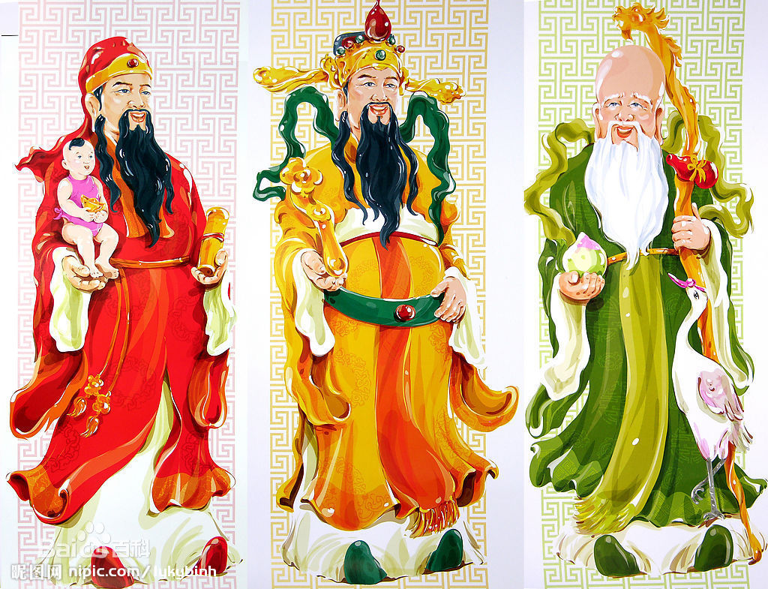
Order 1: let to right are Lu, Fu, Shou. Fu is in the middle.

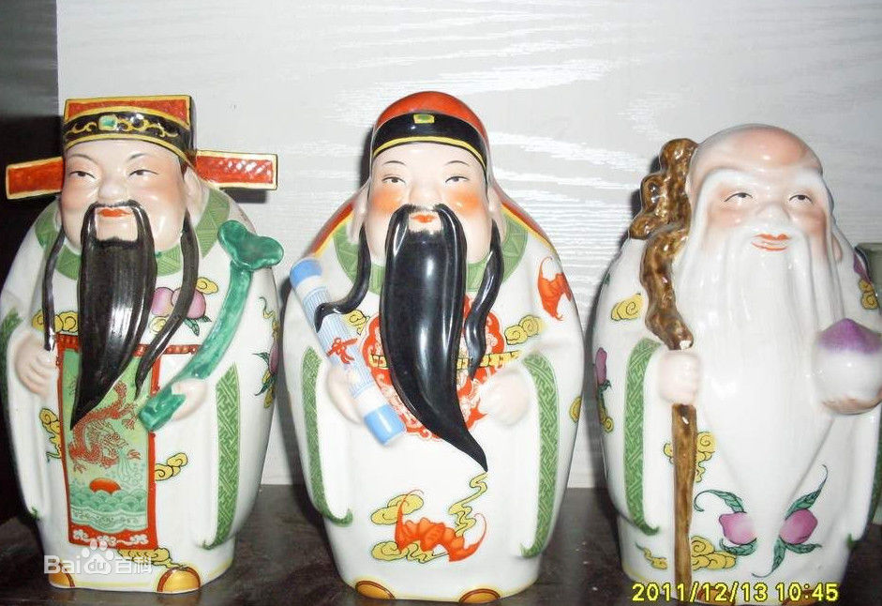
Order 2: left to right are Fu, Lu, Shou.

